# 

# Task 5 – Credit Submission

Student Number: 103542974  
Student Name: Hai Hoang Le

### Credit 5a

Paste your screen capture(s) for this task here.

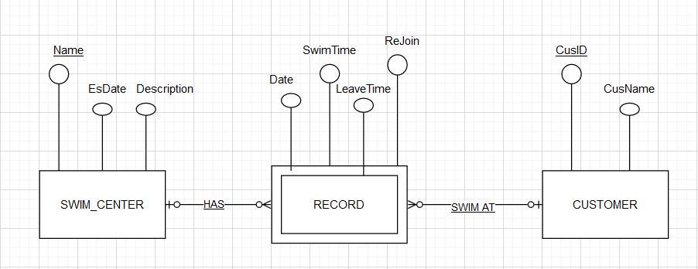

SWIM_CENTER (Name, EsDate, Description)

PRIMARY KEY (NAME)

CUSTOMER (CusID, CusName)

PRIMARY KEY(CusID)

RECORD (Name, CusID, Date, SwimTime, LeaveTime, Rejoin)

PRIMARY KEY (Name, CusID)

FOREIGN KEY (Name) references SWIM_CENTER

FOREIGN KEY (CusID) references CUSTOMER

SWIM_CENTER (Name, EsDate, Description)

Hoa Binh, 15/3/2023, Premium

Landmark, 23/06/2016, Middle

Bitexco, 21/8/2016, Low_cost

CUSTOMER(CusID,CusName)

2802, Hai Le

1968, Harry Potter

2023, Luccas Dio

RECORD (Name, CusID, Date,SwimTime,LeaveTime,Rejoin)

Hoa Binh, 2802, 2/28/2022, 1300, 1500, 14/3/2022

Landmark, 2023, 28/12/2019, 700, 830, 7/1/2022

Bitexco, 1968, 14/2/2023,1500, 2600, 15/2/2023

### Credit 5b

Paste your screen capture(s) for this task here.

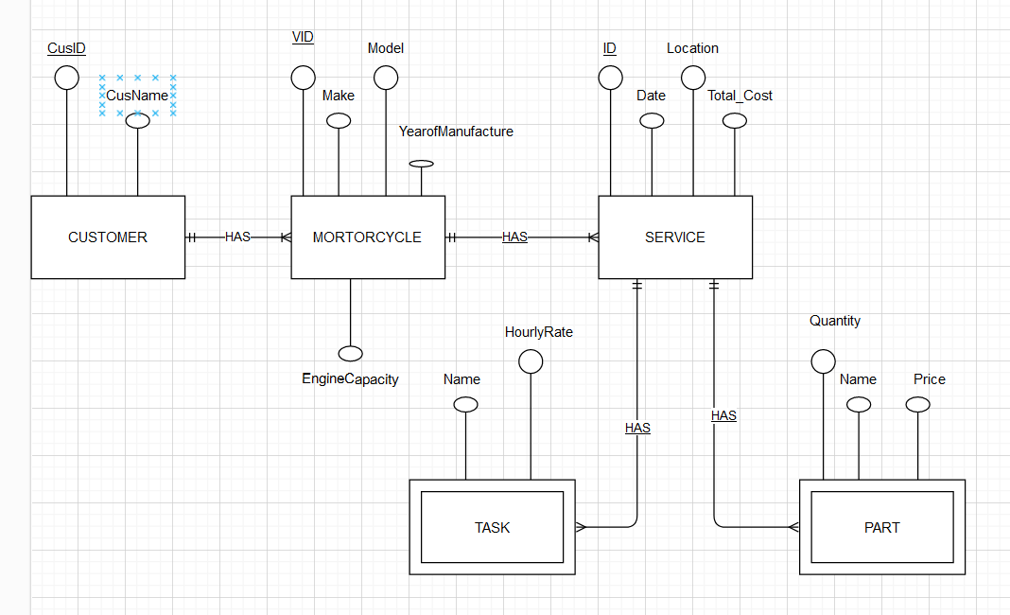

### Credit 5c

Paste your screen capture(s) for this task here.

CUSTOMER (CusID, CusName)

PRIMARY KEY(CusID)

MORTORCYCLE (VID, Make, Model, YearofManufacture, EngineCapacity, CusID)

PRIMARY KEY (VID, CusID)

FOREIGN KEY (CusID) references CUSTOMER

SERVICE (ID, Date, Location, Total_Cost, VID)

PRIMARY KEY (VID, ID)

FOREIGN KEY (VID) references MOTORCYCLE

TASK (Name, HourlyRate, ID)

FOREIGN KEY (ID) references SERVICE

PART (Name, Quantity, Price, ID)

FOREIGN KEY (ID) references SERVICE

### Credit 5d

Paste your screen capture(s) for this task here.

CREATE TABLE CUSTOMER (

CusID INT PRIMARY KEY,

CusName VARCHAR(50)

);

CREATE TABLE MOTORCYCLE (

VID INT,

Make VARCHAR(50),

Model VARCHAR(50),

YearofManufacture INT,

EngineCapacity INT,

CusID INT,

PRIMARY KEY (VID, CusID),

FOREIGN KEY (CusID) REFERENCES CUSTOMER(CusID)

);

CREATE TABLE SERVICE (

ID INT,

Date DATE,

Location VARCHAR(50),

Total_Cost DECIMAL(10, 2),

VID INT,

PRIMARY KEY (VID, ID),

FOREIGN KEY (VID) REFERENCES MOTORCYCLE(VID)

);

CREATE TABLE TASK (

Name VARCHAR(50),

HourlyRate DECIMAL(10, 2),

ID INT,

FOREIGN KEY (ID) REFERENCES SERVICE(ID)

);

CREATE TABLE PART (

Name VARCHAR(50),

Quantity INT,

Price DECIMAL(10, 2),

ID INT,

FOREIGN KEY (ID) REFERENCES SERVICE(ID)

);

### Credit 5e

Paste your screen capture(s) for this task here.

The tables in 3NF will be

Table 1: Customer

|  |  |  |
| --- | --- | --- |
| **CusId** | **Name** | **Phone** |
| 125 | John Coles | 0401112233 |
| 278 | Erin Trump | 0466121455 |
| 721 | Emma Knox | 0423544117 |

Table 2: Car

|  |  |
| --- | --- |
| **CarRego** | **MakeModel** |
| 1AU8HK | Mazda 3 |
| 1LM3AB | Hyundai i30 |
| 1KA2CA | Toyota |
| 1CZ8JK | Mazda 3 |

Table 3: Rental

|  |  |  |  |
| --- | --- | --- | --- |
| **CustId** | **CarRego** | **StartDate** | **ReturnDate** |
| 125 | 1AU8HK | 31/08/2020 | 14/11/2020 |
| 125 | 1LM3AB | 7/09/2020 | 21/11/2020 |
| 278 | 1AU8HK | 12/09/2020 | 1/10/2020 |
| 278 | 1KA2CA | 10/11/2020 | 26/11/2020 |
| 278 | 1CZ8JK | 12/11/2020 | 1/12/2020 |
| 721 | 1LM3AB | 10/09/2020 | 13/09/2020 |

### Credit 5f

Paste your screen capture(s) for this task here.

### For the Purchase Transaction:

### BEGIN TRANSACTION

### DECLARE @prodCost money, @qtyInStock int

### SELECT @prodCost = PricePerOne * ABS(ProdQty), @qtyInStock = QtyInStock - ABS(ProdQty)

### FROM Product WHERE ProdID = 'G43546'

### UPDATE Product SET QtyInStock = @qtyInStock WHERE ProdID = 'G43546'

### COMMIT TRANSACTION

**For the Return Transaction**

### BEGIN TRANSACTION

### DECLARE @prodCost money, @qtyInStock int

### SELECT @prodCost = PricePerOne * ABS(ProdQty), @qtyInStock = QtyInStock + ABS(ProdQty)

### FROM Product WHERE ProdID = 'G43546'

### UPDATE Product SET QtyInStock = @qtyInStock WHERE ProdID = 'G43546'

### COMMIT TRANSACTION